
Contestant Number:
Time:
Rank:

COLLEGE PAYROLL ACCOUNTING
(130)

—Post-secondary—

STATE – 2020

Multiple Choice (20 @ 2 points each) (40 points)

Short Answer Questions: Calculations (36 points)

Problem Section:

Problem 1: Form 940 (28 points)
Problem 2: Payroll Register (57 points)
Problem 3: Payroll Register & Journal Entries (71 points)

TOTAL POINTS (232 points)

Failure to adhere to any of the following rules will result in disqualification:
- Contestant must hand in this test booklet and all printouts. Failure to do so will result in disqualification.
- No equipment, supplies, or materials other than those specified for this event are allowed in the testing area. No previous BPA tests and/or sample tests or facsimile (handwritten, photocopied, or keyed) are allowed in the testing area.
- Electronic devices will be monitored according to ACT standards.

No more than ten (10) minutes orientation
No more than ninety (90) minutes testing time
No more than ten (10) minutes wrap-up

Property of Business Professionals of America.
May be reproduced only for use in the Business Professionals of America
Workplace Skills Assessment Program competition.

General Instructions

You have been hired as a Financial Assistant and will be keeping the accounting records for Professional Business Associates, located at 5454 Cleveland Avenue, Columbus, Ohio 43231. Professional Business Associates provides accounting and other financial services for clients. You will complete jobs for Professional Business Associates’ own accounting records, as well as for clients.

You will have 90 minutes to complete your work. The test is divided into two parts. The multiple choice and short answer questions should be completed first, and then the accounting problems may be completed in any order.

Your name and/or school name should NOT appear on any work you submit for grading. Write your contestant number in the provided space. Staple all pages in order before you turn in your test.

Assumptions to make when taking this assessment:

- Calculate all calculations to four (4) decimals, then round to the nearest cent.
- 2019 Payroll Tax Rules Apply
- Social Security (OASDI): 6.2% on the first $132,900
- Medicare (HI): 1.45%
- FUTA: .6% on first $7,000 of employee wages
- SUTA: Information is in each question

Multiple Choice: (40 points, 2 each) Choose the letter which best answers the question or completes the sentence.

- Which transaction is not a type of payroll accounting entry?
a. Standard Entry
b. Tax Withholding Entry
c. Payroll Tax Entry
d. Wage Entry

- Employers must deposit on the following schedule if their payroll tax obligation is $100,00 or more:
  - Weekly
  - Semi-weekly
  - Monthly
  - None of the above

- Tip credit is reported on:
  - Form 941
  - Form 8846
  - Form W-2
  - Form 940

- Wages are:
  - The pay earned by piece-rate employees
  - The pay earned by salary-paid employees
  - The pay earned by hourly-paid employees
  - All of the above
  - Only a & c

- The form where an employee reports the number of allowances to be used in calculating the amount of federal income tax to be withheld is
  - Form W-2
  - Form I-9
  - Form W-4
  - Form 941

- Payroll taxes levied by the city or county are called
  - Garnishment
  - Commissions
  - Deferred Taxes
  - Local Taxes

- A tax paid by the employer that is 0.6% of the employees first $7,000 of annual salary or wages is called:
  - FUTA
  - FIT
  - SWT
  - SUTA
- The combination of Social Security Tax and Medicare Tax is referred to by an acronym:
  - FUTA
  - OASDI
  - SSHI
  - FICA

- The Employment Eligibility Form is called:
  - Form W-4
  - Form I-9
  - Form 944
  - Form 940

- Abby Lincoln is paid a salary of $48,950 Semi-monthly, what is her gross pay each pay period?
  - $1,882.69
  - $2,039.58
  - $941.35
  - $4,079.17

- Lyndie Johnson is paid a salary of $62,950 Semi-monthly, and contributes 10% of her salary to her 401(K), what is her gross pay each pay period?
  - $2,421.15
  - $2,179.04
  - $2,622.92
  - $2,560.63

- Rebecca Jefferson is a full time student paid and works in a retail clothing store. Her minimum wage could be calculated at:
  - $7.50 per hour
  - $7.25 per hour
  - $2.13 per hour
  - $4.25 per hour

- Jamie Madison is a 16 year old high school student who was hired 10 days ago. Her minimum wage is:
  - $7.30 per hour
  - $6.16 per hour
  - $2.13 per hour
  - $7.25 per hour

- The Fair Labor and Standards Act guarantee pay for the following:
  - Holiday Pay
  - Vacation Pay
  - Overtime Pay
  - All of the above

- The IRS Safe Harbor Rule allows payroll tax depositors to deposit a shortfall of _____ without a penalty.
  - $250 or 2.5%
  - $250 or 2%
  - $100 or 2.5%
  - $100 or 2%

- The Tax Liability Report for semi-weekly depositors is
  - Form W-4
  - Form I-9
  - Form 941
  - Form 940

- Under the Affordable Care Act, which rate goes up .9% when a single taxpayer earns over $200,000?
a. SSI
b. HI
c. FIT
d. none of the above

- When are tips not taxable for OASDI/HI purposes?
a. Tips shared with other staff
b. Tips while receiving Holiday Pay
c. Tips less than $20 per month
d. Tip share while on Vacation Pay

- Remuneration paid every twice a month is called
  - Semi-monthly
  - Bi-weekly
  - Bi-monthly
  - Semi-annual

- What is the taxable limitation for OASDI on wages for 2019
a. $121,200
b. $124,400
c. $132,900
d. $200,000

Short Answer Questions: (36 points)

- Marsha Van Buren earns an annual salary of $73,215 for a 40 hour work week. Complete the following gross pay chart: (4 points each)

Monthly | Semi-monthly | Bi-weekly | Weekly | Hourly Rate | Overtime Rate

- Jenny Quincy Adams worked 42.25 hours on a weekly payroll job including an 8 hour shift on a holiday; her rate of pay is $17.25 per hour. If the company she works for uses the Overtime Premium method and pays double time for holidays, answer the following questions regarding Jenny’s weekly pay? (2 points each)

Regular Earnings $_______________________
Holiday Earnings $_______________________
Overtime Earnings $_______________________
Total Earnings $_______________________

- Greta Cleveland earns an hourly wage of $9 per hour and a 10% shift differential for working late evenings (after 10 pm). If she works the following hours, with a one hour lunch break from
7pm-8pm, what was her gross pay? (8 points)

Monday | Tuesday | Wednesday | Thursday | Friday
3pm-12am | 3pm-12:30am | 3pm-12am | 3pm-12am | 3pm-12:15am

$___________________________________

- Donna Eisenhower earns a salary plus bonus commission on sales and is paid weekly. Her regular salary is $685 per week. She earns an extra 4.6% on all net sales over $1,750 per pay period. During this pay period she had the following sales and merchandise returns. (3 points each)

Sales $ 2,478 Sales Returns $ 361

Answer the following questions regarding Donna’s gross pay for this pay period.
Regular Wages $
Sales Subject to Commission $
Commission Earnings $
Total Earnings $

Problems:
- Use the following information to complete the Form 940 for the Monument City Tour Company located at 555 President Street, Baltimore, Maryland, 11111. MCT’s Federal ID number is
12-3456789 and are not subject to a credit reduction. MCT has the following wages paid in 2018 and did not deposit any FUTA tax during the year. (28 points, 2 points each)
Employee #1 | Employee #2 | Employee #3 | Employee #4 | Employee #5
$43,988.50 | $68,654.21 | $74,523.55 | $55,655.44 | $63,857.36
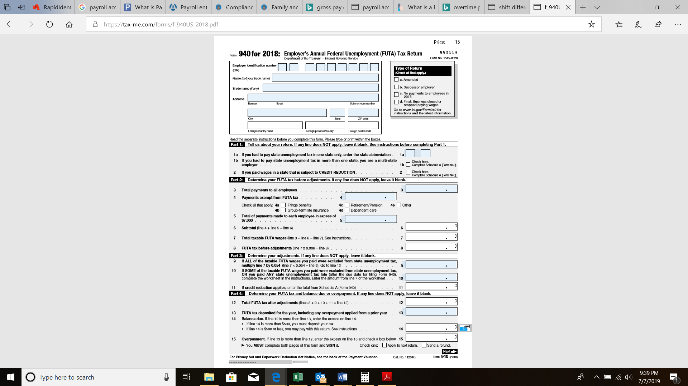
- (57 points, 1 each)
Complete the following Payroll Register for Smithsonian Corporation. All employees are paid by the hour, assume all employees are Single, have 0 withholding allowances, and are paid weekly. Use the provided withholding tables to find the FIT withholding.
 |  |  |  |  |  | Payroll Register
 | Reg. | Reg. | OT | OT | Total |  |  | Deductions
NAME | Hours | Rate | Hours | Rate | Wages | OASDI | HI | FIT | Pre-tax Group Ins. | 401K | Net Pay
Harry | 39 | 12.56
Franklin | 37 | 13.24 |  |  |  |  |  |  | 15.00 | 15.00
Herbert | 35.75 | 11.80
Dwight | 40 | 11.67 | 2.25 |  |  |  |  |  | 15.00 | 55.00
Lyndon | 38.5 | 10.42 |  |  |  |  |  |  | 15.00
George | 40 | 9.25 | 1.75 |  |  |  |  |  | 15.00 | 20.00
Jimmy | 32.25 | 9.88
Ronald | 34 | 10.35 |  |  |  |  |  |  |  | 15.00
TOTALS |  | XXX |  | XXX

- (71 points, 1 each payroll register; 2 points each on journal entries)
Complete and total the Payroll Register and journalize the payroll and employer’s taxes using Freedom Bell’s Payroll Register below. This is the first payroll of the year. All employees are paid by the hour weekly. The pay period ends on 1/4/18 and the pay date is 1/11/18. The SUTA rate is 3.65%.
Use the provided withholding tables to find the FIT withholding.
 |  |  |  |  |  | Payroll Register
 | Reg. | Reg. | OT | OT | Total | Deductions
NAME | Hours | Rate | Hours | Rate | Wages | OASDI | HI | Allowances | FIT | Post-tax Group Ins. | 401K | Net Pay
Barbara | 39 | 12.62 |  | 18.93 | 492.18 | 30.52 | 7.14 | S/2 |  | 12.00 | 15.00
Hillary | 40 | 11.85 |  | 17.78 | 474.00 | 29.39 | 6.87 | S/3 |  | 12.00 | 45.00
Michelle | 40 | 12.25 | 5 | 18.38 | 581.90 | 36.08 | 8.44 | S/4 |  | 12.00 | 25.00
TOTALS |  | XXX |  | XXX |  |  |  | XXX

ACCOUNT NUMBERS TO USE FOR POST REFERENCE:
11- CASH 22- OASDI PAYABLE 23- HI PAYABLE
24- FIT PAYABLE 25- 401K PAYABLE 26 – IINSURANCE PAYABLE
27- FUTA PAYABLE 28- SUTA PAYABLE 53- WAGES EXPENSE \
54-PAYROLL TAX EXPENSE

 | JOURNAL |  | PAGE 1
DATE | ACCOUNT DESCRIPTION | DEBIT | CREDIT

